The APPLET tag of HTML is used to start an applet either from a web browser or an applet viewer.The HTML tag allows a Java applet to be embedded in an HTML document.

The complete syntax of the applet tag is given below:

<applet

code = "applet File"

width = "pixels"

height = "pixels“

[codebase = "codebaseURL"]

[alt = "alternateText"]

[name = "appletlnstanceName"]

[align = "alignment"]

[vspace = "pixels"]

[hspace = "pixels"] >

[<param name = "appletAttribute1" value = "value">]

[<param name = "appletAttribute2" value = "value">

</applet>

**PARAMETERS**

**Code-**The name of the Java applet. Class file, which contains the compiled applet code. This name must be relative to the base URL of the Applet.The extension in the file name is optional.

**width*-***This refers to the width of the applet panel specified in pixels in the browser window.

**Height-**This refers to the height of the applet panel specified in pixels in the browser window. The width and height attributes specify the applet's display area.

**Codebase -**This refers to the base URL of the applet. That is, the URL of the directory that contains the applet class file. If this attribute is not specified then the HTML document's URL directory is taken as the CODEBASE.

**alt***-*This refers to text to be displayed if the browser understands the applet tag but cannot run Java applets.

**name**This refers to a name for the applet instance which makes it possible for applets to communicate with each other on the same HTML page.The getApplet () method, which is defined in the AppletContext interface, can be used to get the applet instance using name.

**align**This refers to the alignment of the applet. The possible attribute values are LEFT, RlGHT, TOP, BOTTOM, MIDDLE, BASELINE, TEXTTOP, ABSMIDDLE and ABSBOTTOM.

**vspace**This refers to the space, specified in number of pixels, used as a margin above and below the applet.

**hspace**This refers to the space, specified in number of pixels, used as a margin to the left and right of the applet.

**param**The param tag, specifies an applet parameter as a name-value pair. The name is the parameters name, value is. its value. The values of these parameters can be obtained using the getParameter () method.

**alternateHTML**This is ordinary HTML to be displayed in the absence of Java or if the browser does not understand the applet tag. This is different from the alt attribute which understands the· applet tag but cannot run, whereas the alternateHTML tag is provided when a browser does not support applets.

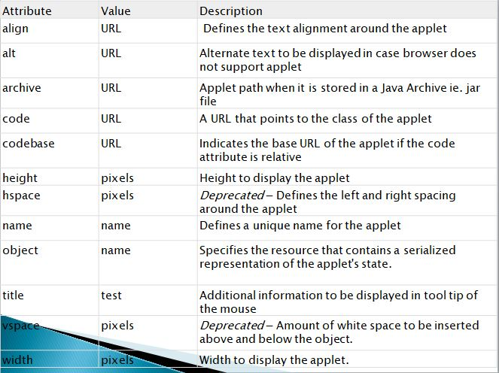

Note-there are few browsers which donot support applets.eg-google chrome,internet explorer,opera

Browsers that supports applet are Mozilla firefox and safari.